InComm

Error Handler & Logging Framework Deployment PreRequisite

Version <1.0>

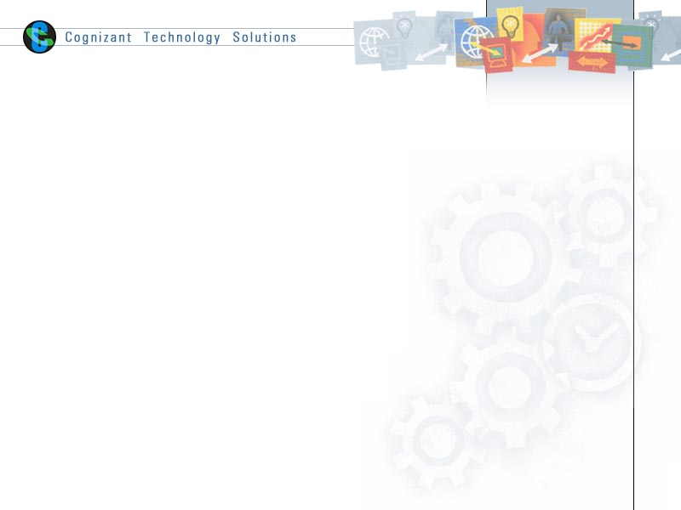

|  |  |  |  |
| --- | --- | --- | --- |
|  | **Prepared By / Last Updated By** | **Reviewed By** | **Approved By** |
| **Name** | Yogesh Basavarajaiah |  |  |
| **Role** |  |  |  |
| **Signature** |  |  |  |
| **Date** | 8 June 2015 |  |  |

Table of Contents

1.0 Document Overview 3

1.1 Document Purpose 3

1.2 References 3

1.3 Definitions, Acronyms and Abbreviations 3

2.0 Create Factories & Queues 3

3.0 Appendix A – Change Log 4

# Document Overview

## Document Purpose

This document is intended to provide guideline on prerequisite for deploying TIBCO BW code for Error Handler & Logging framework.

## References

Use this section to fill-in reference documents used

|  |  |
| --- | --- |
| ***Document#*** | ***Document Title*** |
|  |  |
|  |  |

## Definitions, Acronyms and Abbreviations

Use this section to fill-in definitions of acronyms & abbreviations used in this document

|  |  |
| --- | --- |
| ***Term, Acronym*** | ***Definition*** |
|  |  |
|  |  |

# Create Factories & Queues

We need to create Queue & Topic Connection Factories in EMS before deploying Error Handling Code:

Queue Connection Factory name is in Module Properties:

/Resources/JMS/Exception/QueueConnectionFactory = QueueConnectionFactory

Topic Connection Factory name is in Module Properties:

/Resources/JMS/Exception/TopicConnectionFactory = TopicConnectionFactory

Open EMS Administration Tool and execute below commands which creates Queue & Topic Connection Factories:

connect tcp://10.4.124.167:7222

create factory QueueConnectionFactory queue

create factory TopicConnectionFactory topic

We need to create 2 queues in same EMS server, below are the 2 queues to be created:

/ExceptionHandler/ExceptionQueue= COM.INCOMM.COM.SHAREDSERVICES.ERRORHANDLING.EXCEPTIONQUEUE

/CallLogger/LogQueue = COM.INCOMM.COM.SHAREDSERVICES.ERRORHANDLING.LOGQUEUE

create queue COM.INCOMM.COM.SHAREDSERVICES.ERRORHANDLING.EXCEPTIONQUEUE

create queue COM.INCOMM.COM.SHAREDSERVICES.ERRORHANDLING.LOGQUEUE

# Appendix A – Change Log

|  |  |  |  |  |
| --- | --- | --- | --- | --- |
| ***Version Number*** | ***Changes Made*** | | | |
| V1.0 | Initial baseline created on 08-June-2015 | | | |
| Vx.y |  | | | |
| **Section No.** | **Changed By** | **Effective Date** | **Changes Effected** |
|  |  |  |  |
| Vx.y |  | | | |
| **Section No.** | **Changed By** | **Effective Date** | **Changes Effected** |
|  |  |  |  |
| Vx.y |  | | | |
| **Section No.** | **Changed By** | **Effective Date** | **Changes Effected** |
|  |  |  |  |